Microsoft Azure Site Recovery

[Set up VMware VM disaster recovery to Azure with Azure Site Recovery - Azure Site Recovery | Microsoft Docs](https://docs.microsoft.com/en-us/azure/site-recovery/vmware-azure-tutorial)

Resource group = FGH_DR_RG

Network = FGH_ASRnet – 10.1.0.0/24

Vault = FGHDRVault

MicrosoftAzureSiteRecoveryConfigurationServer

Vlan300

10.224.100.15

User = Administrator

PW = (Mxxxxxxxxxx)

Computername = FGHASR

Registered using username [snl007365@freemansgrattanholdings.onmicrosoft.com](mailto:snl007365@freemansgrattanholdings.onmicrosoft.com)

Log onto the Config server VM and the config wizard starts.

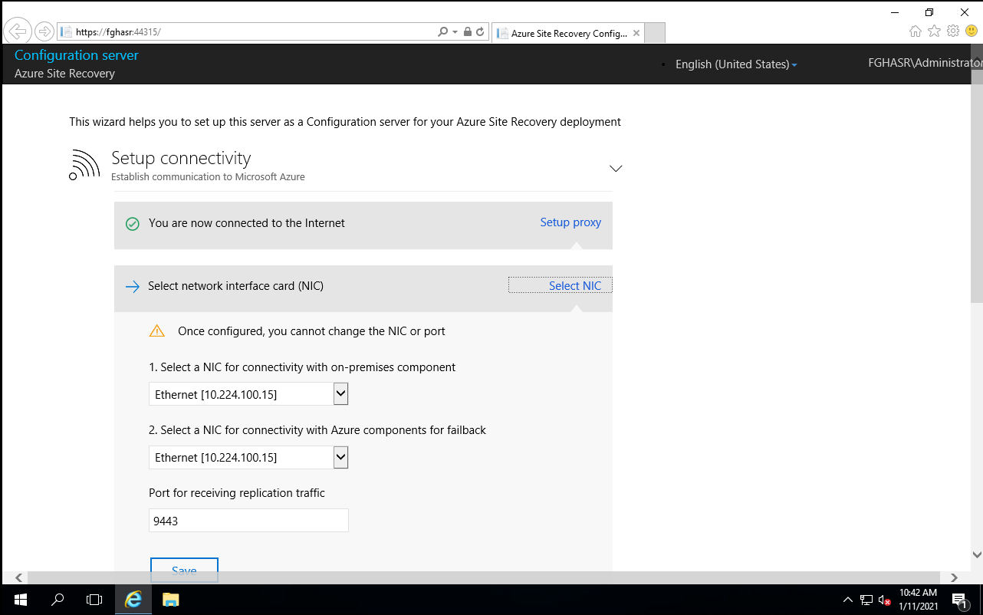

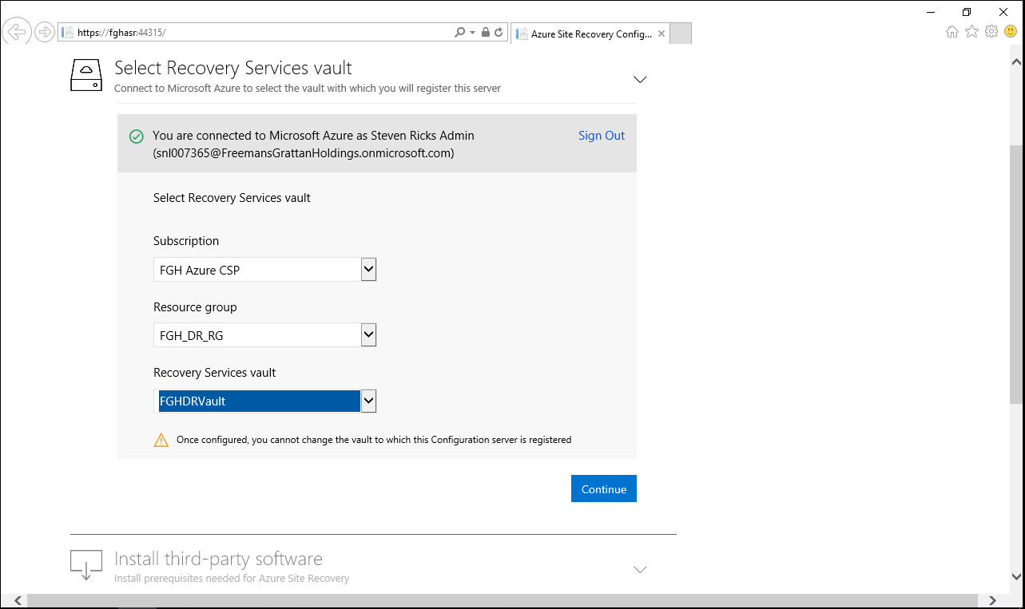

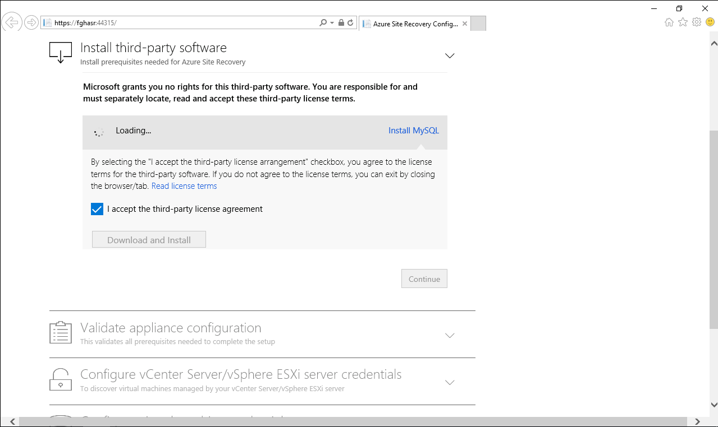

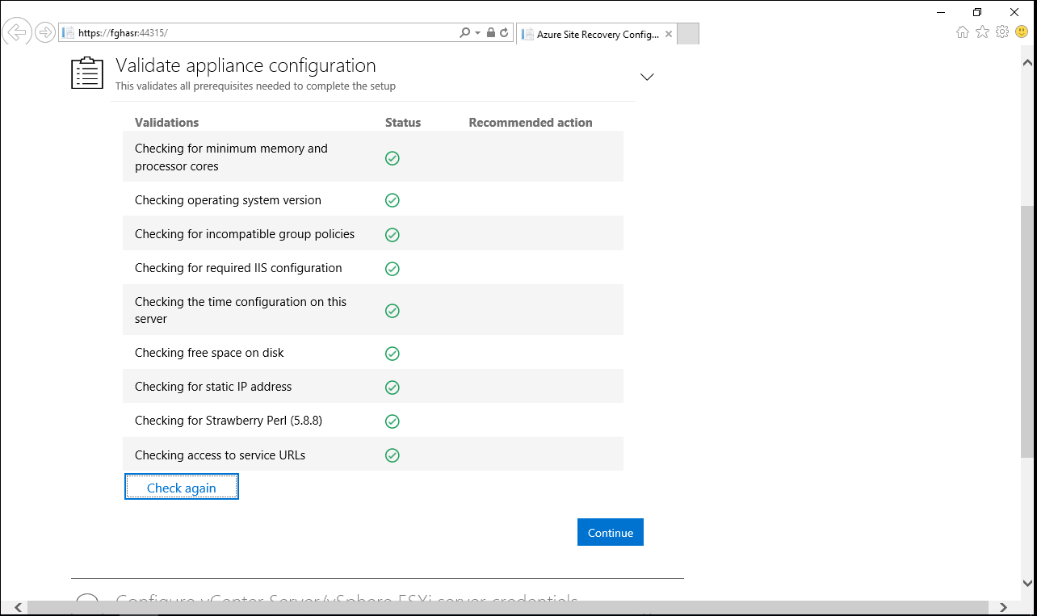

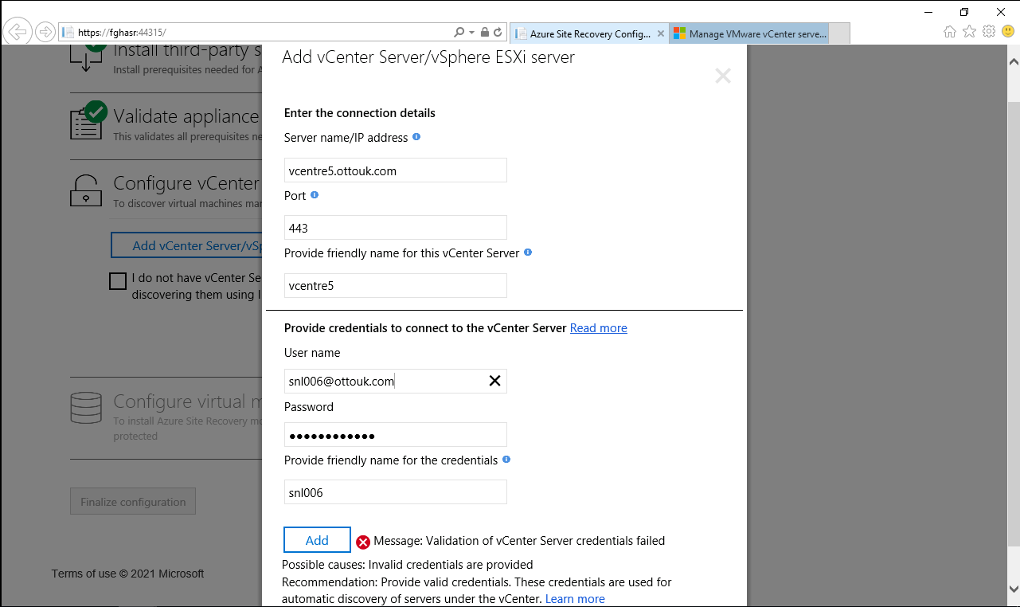

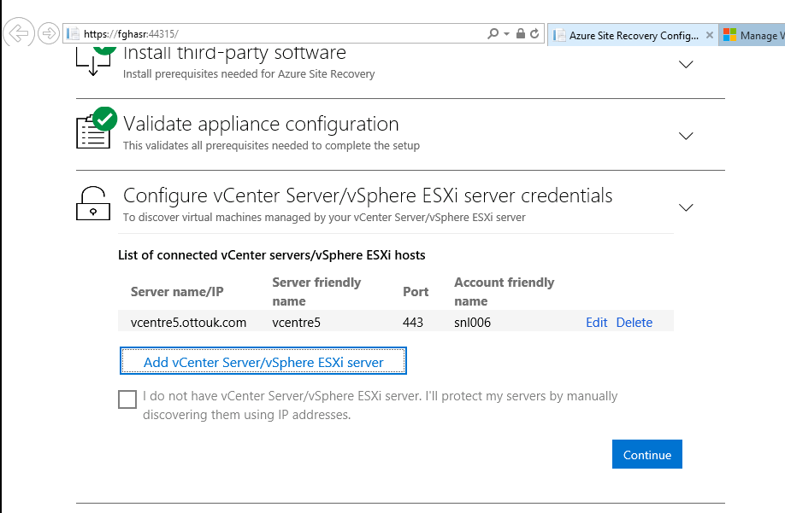

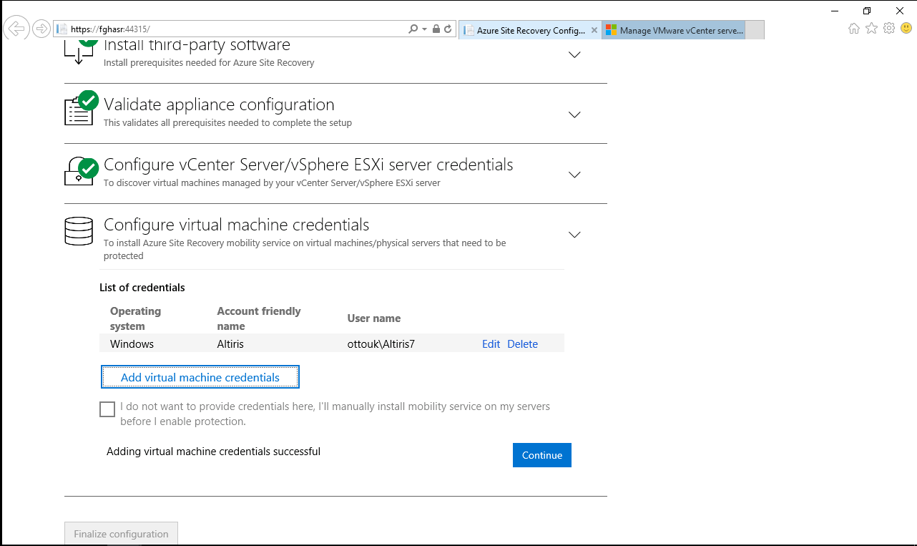

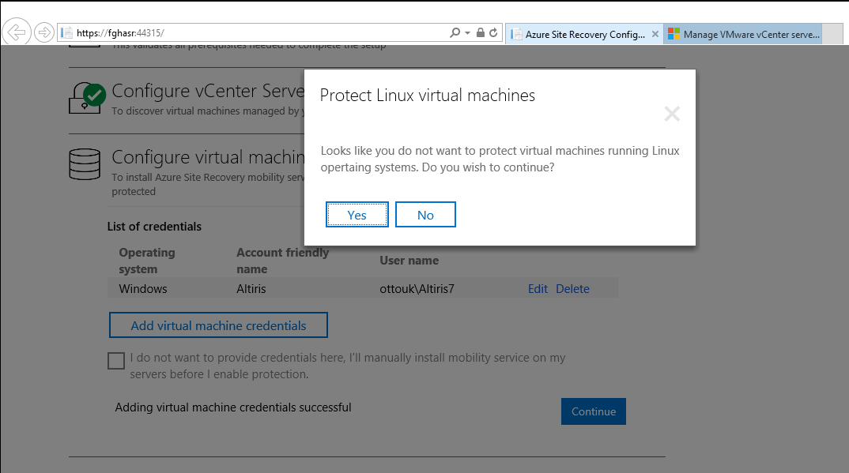

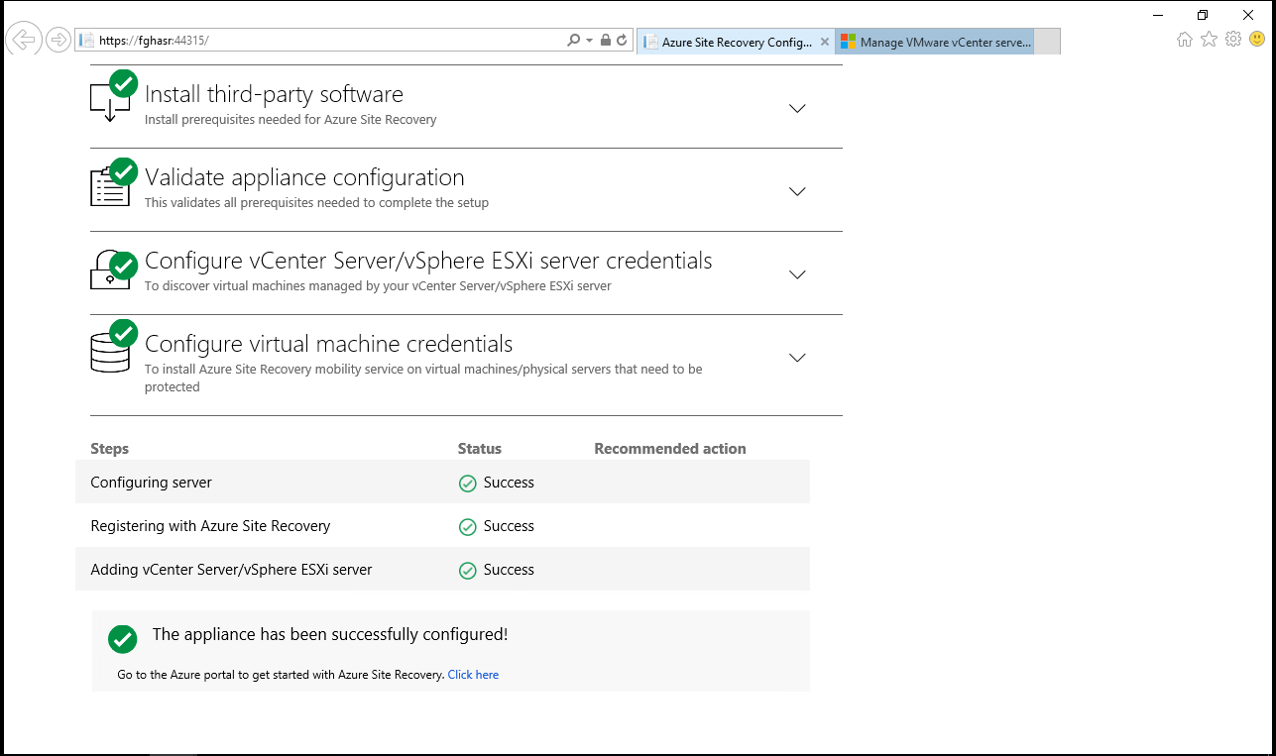

# On Azure portal

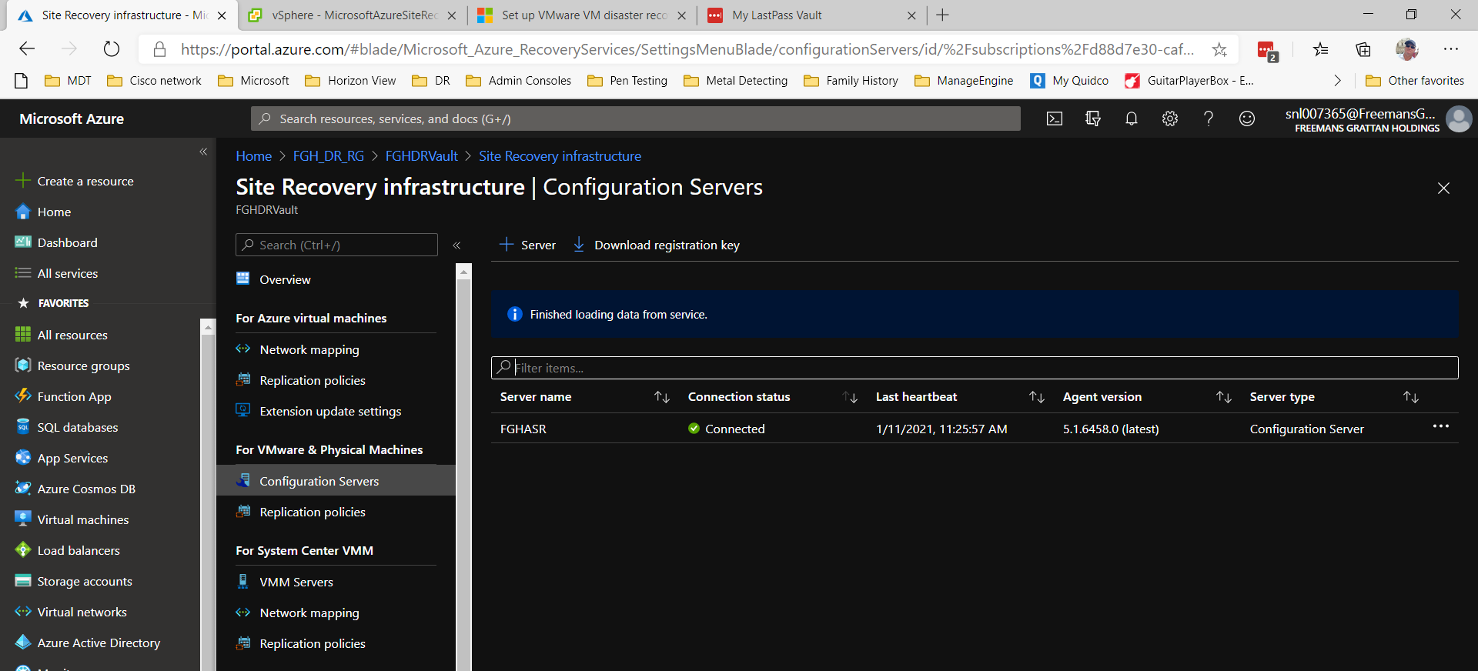

Prepare Infrastructure

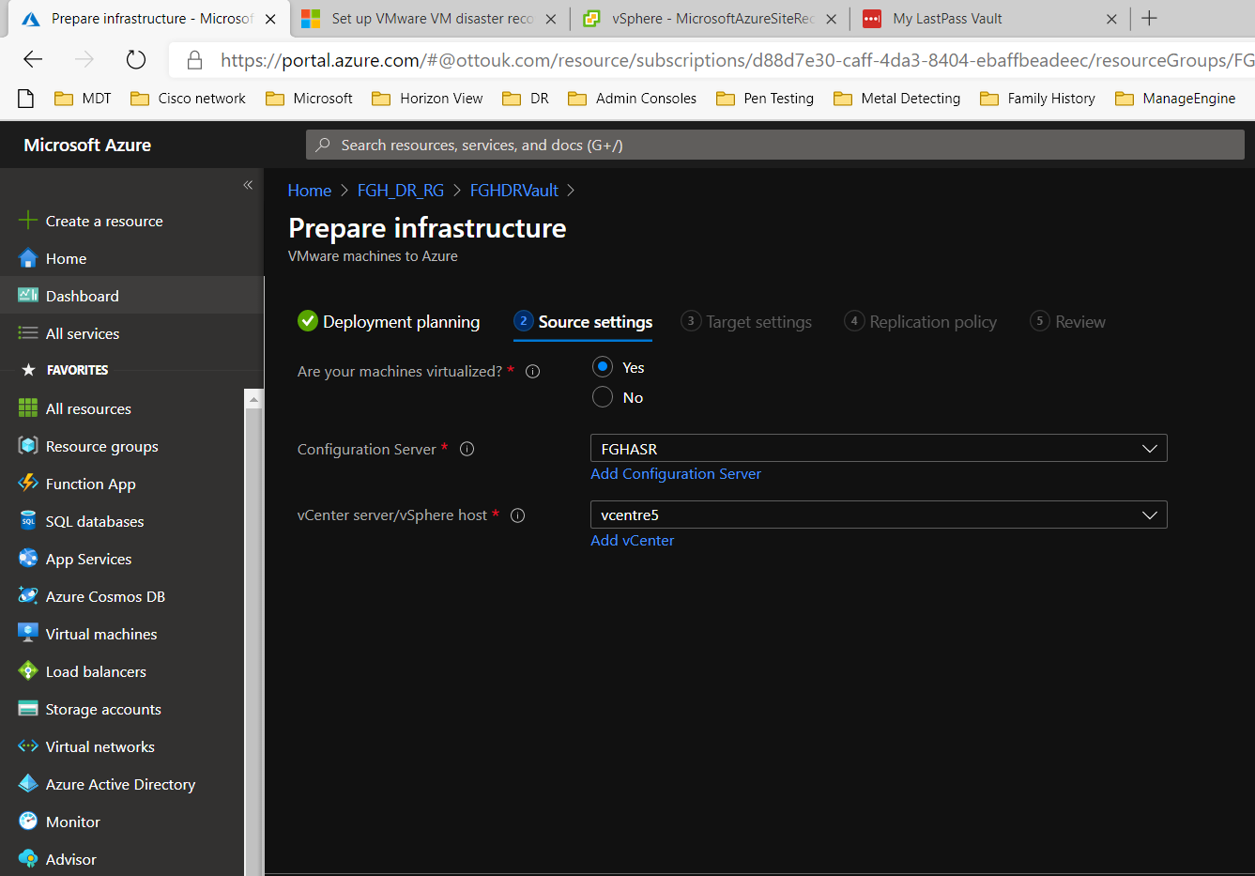

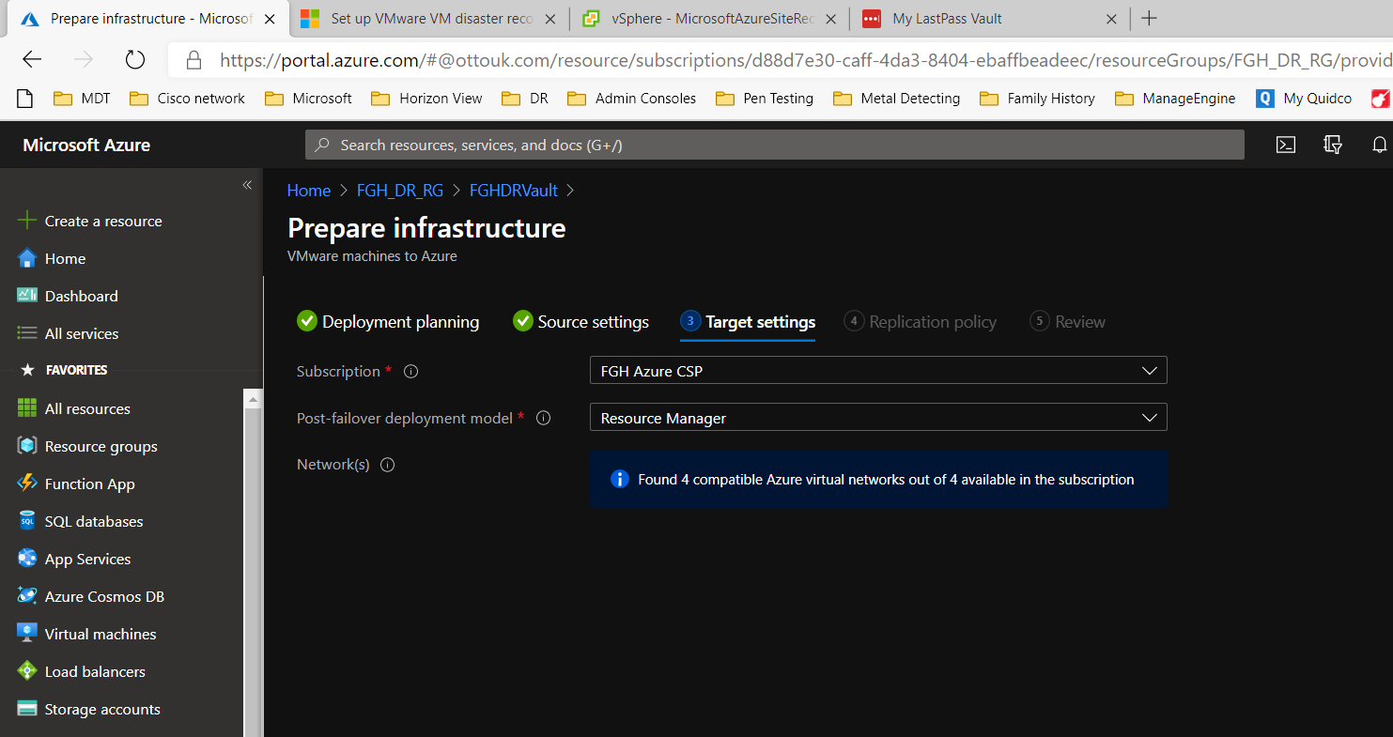

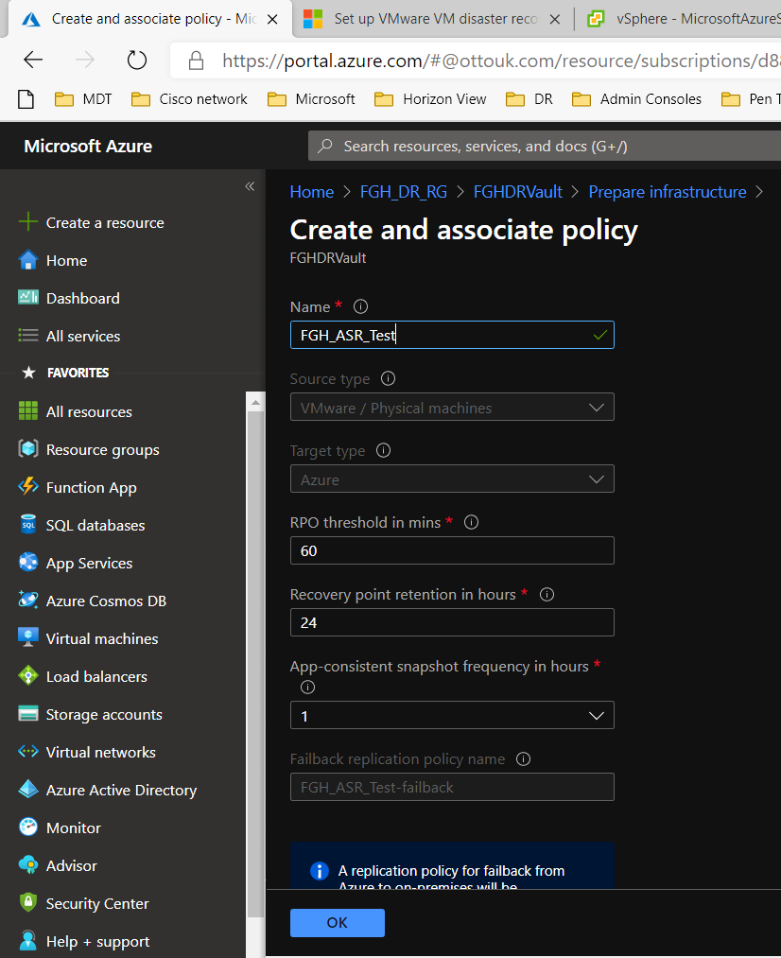

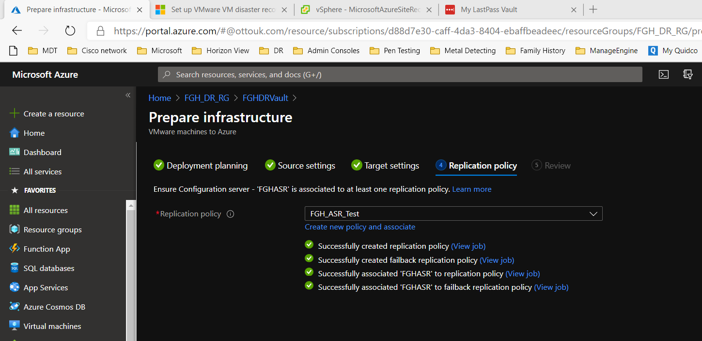

Enable Replication

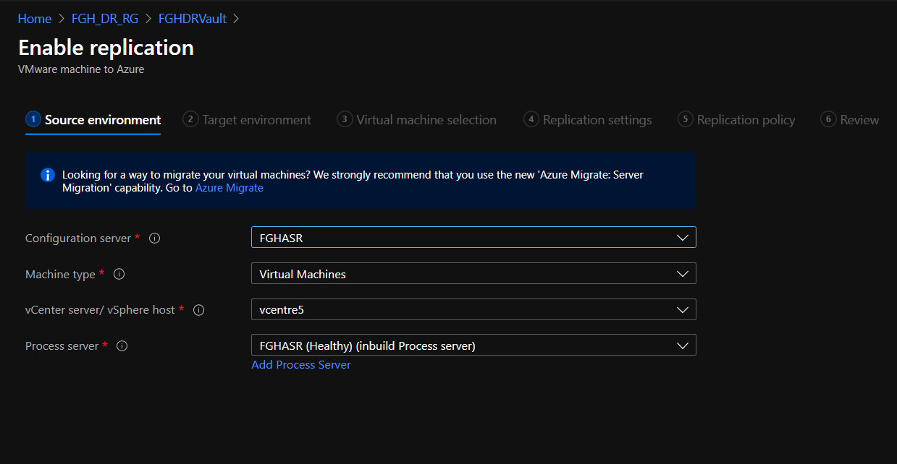

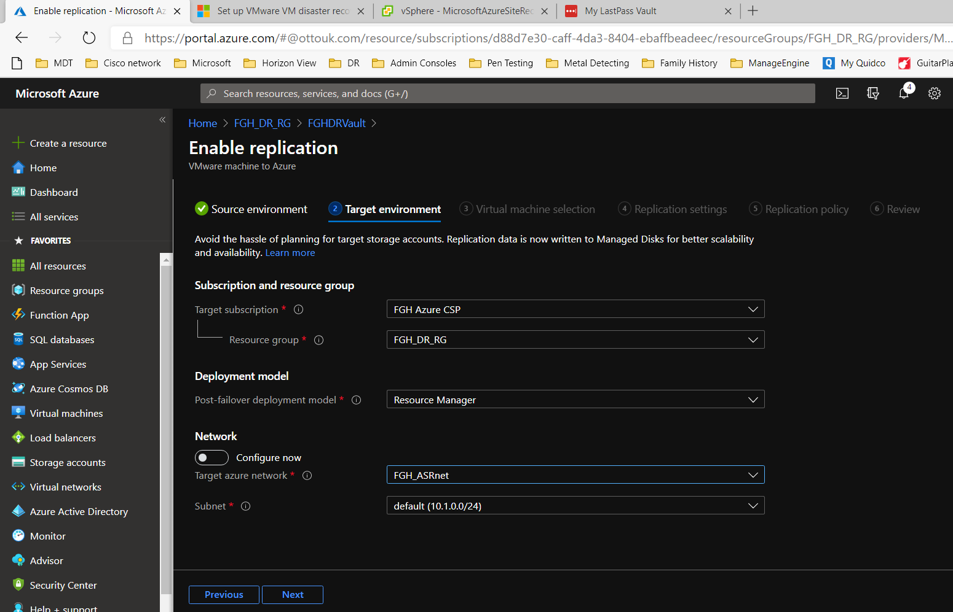

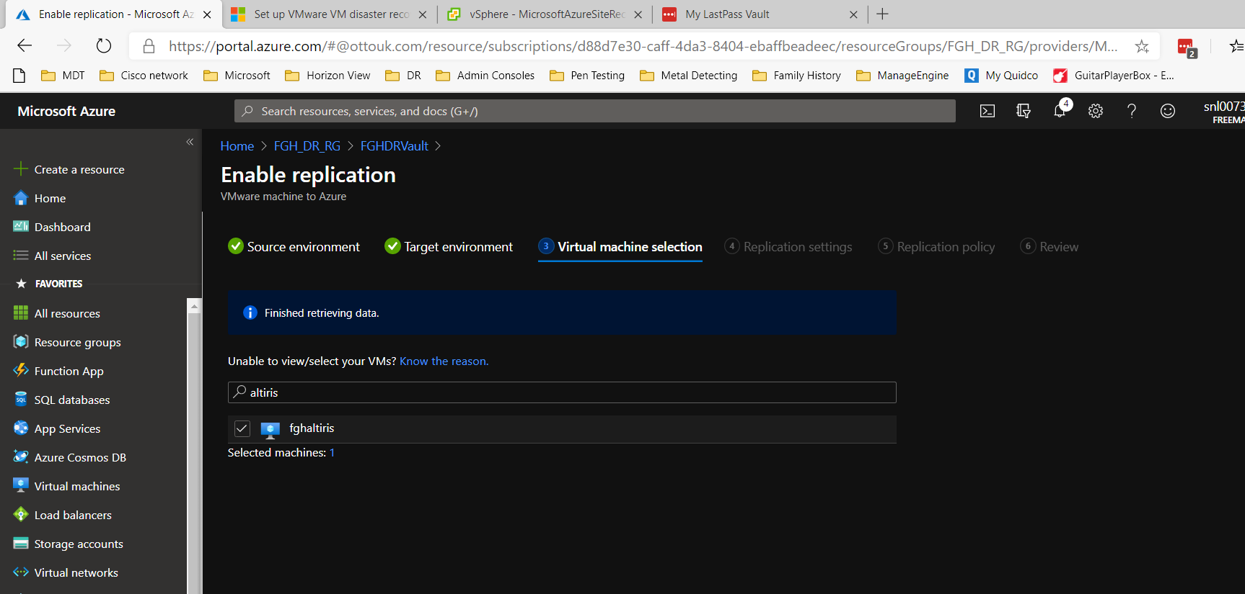

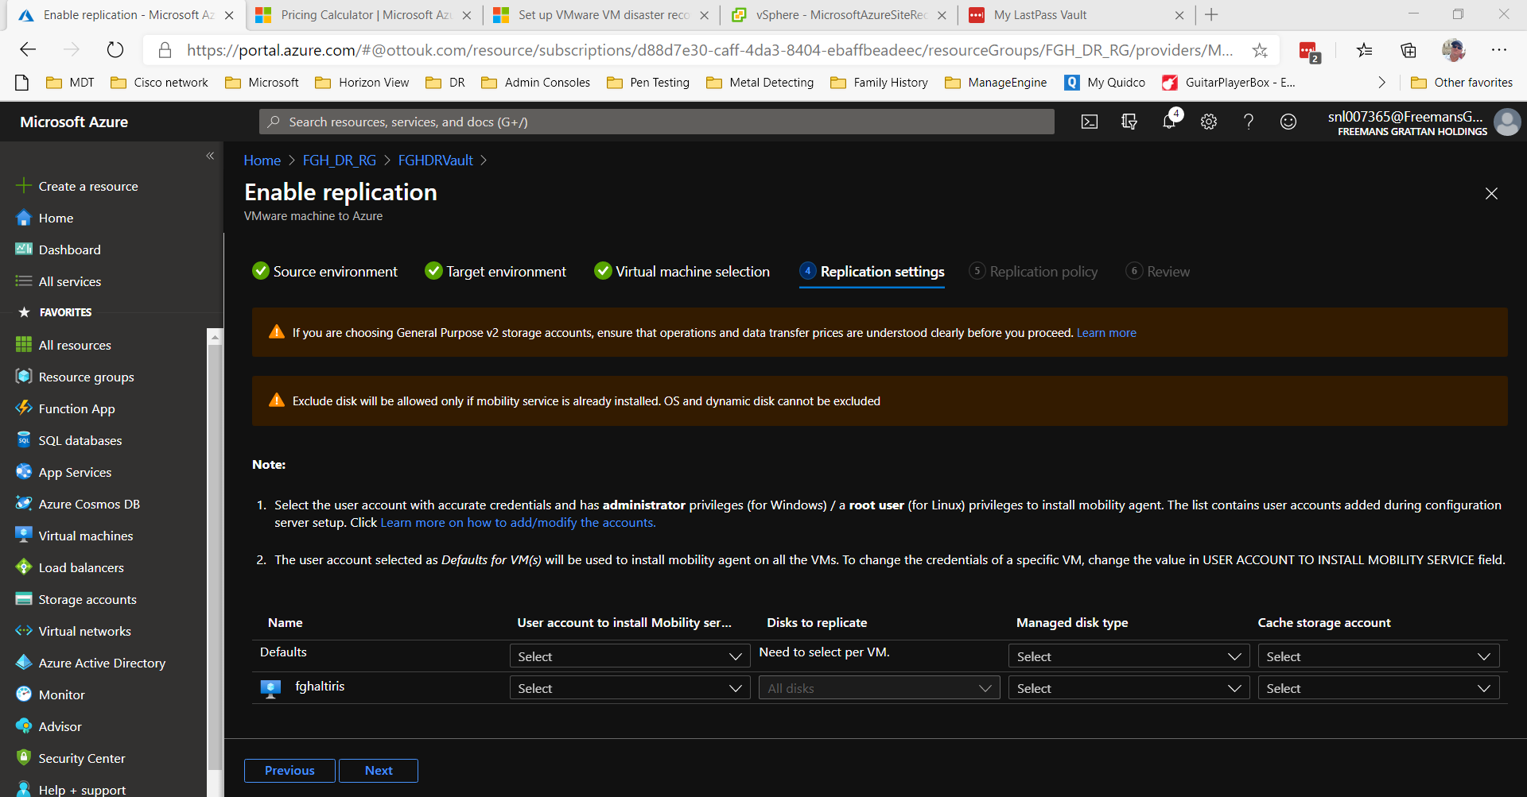

Had to create cache storage at this point. The guide had not mentioned it before.

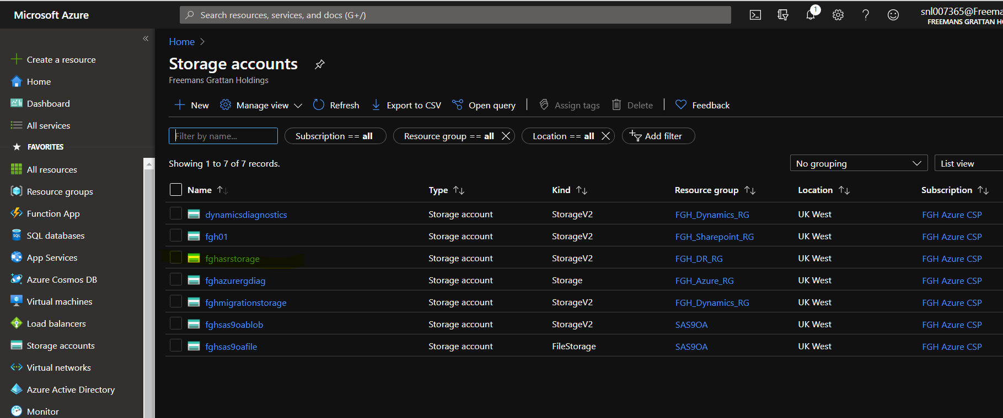

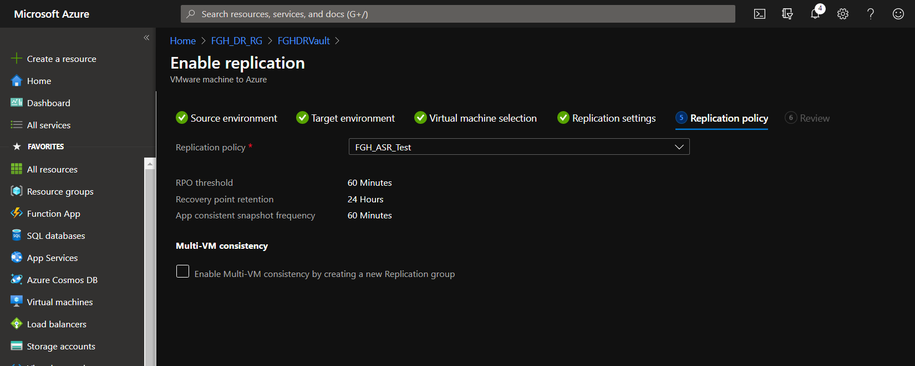

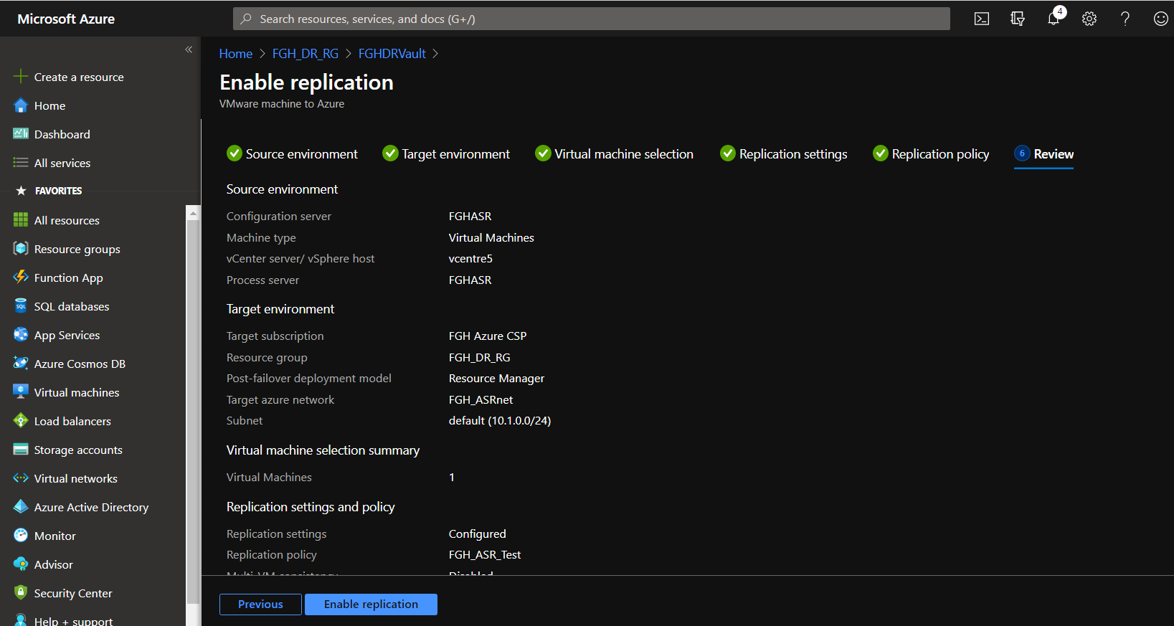

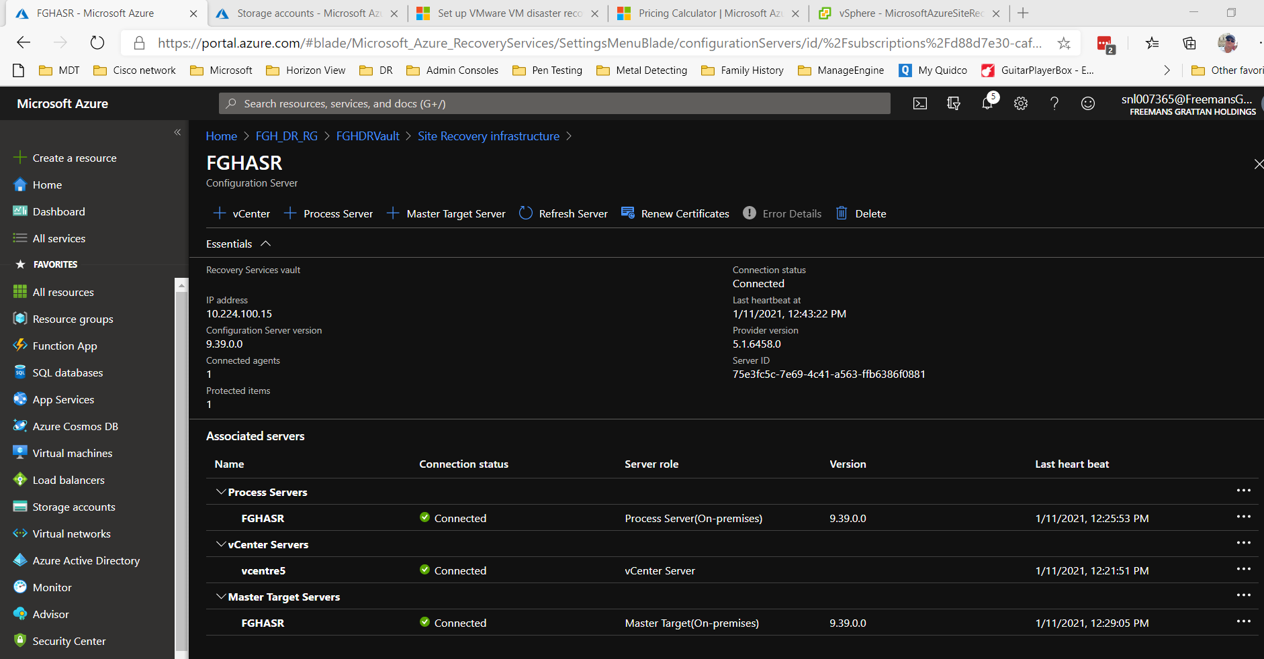

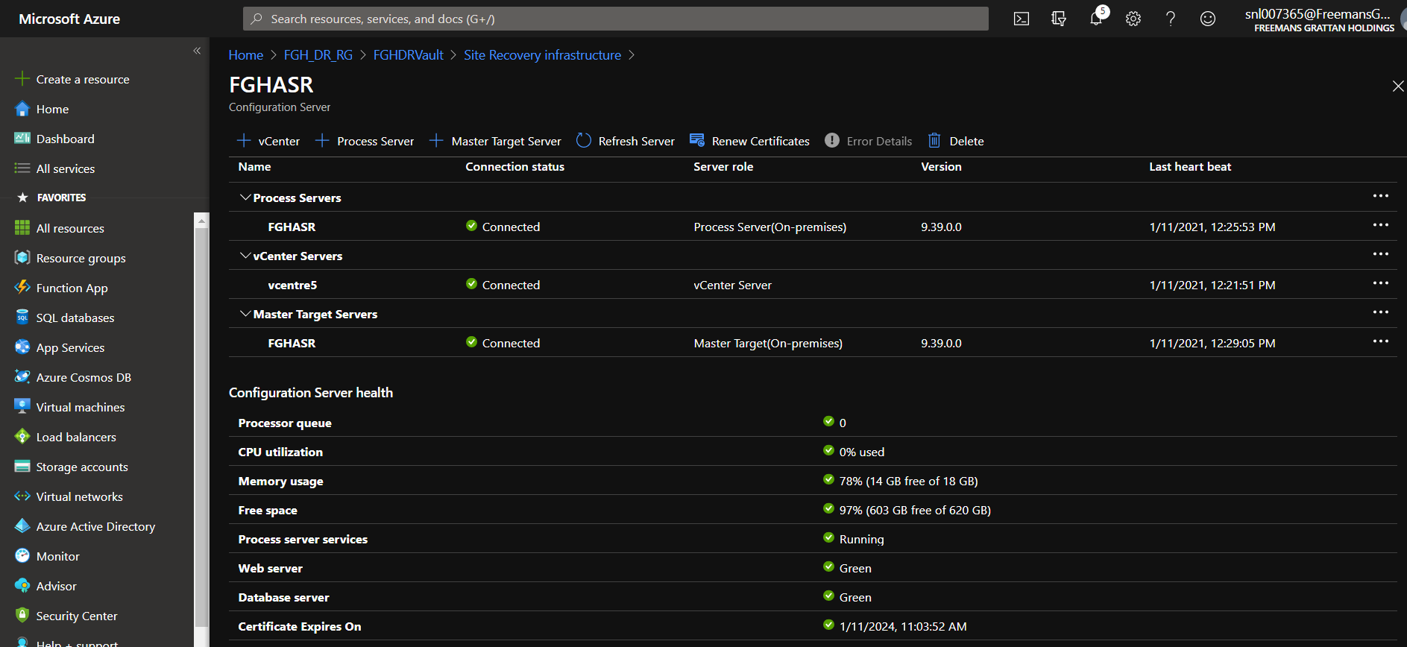

To see replicated servers.

